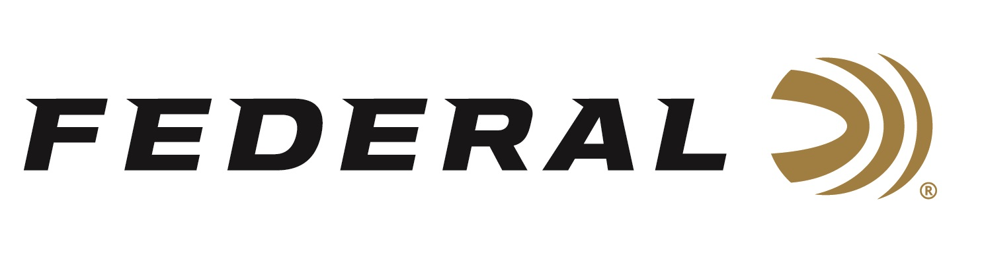

FOR IMMEDIATE RELEASE

Smith Wins Gold, Hancock Claims Silver at ISSF World Cup

ANOKA, Minnesota – May 11, 2021 – Team Federal congratulates Austen Smith on a gold medal performance at the ISSF World Cup being held in Lonato Del Garda, Italy. In a tune up for the Olympics later this summer, Smith bested a field of sixty competitors from all over the world in the Women’s Skeet event on Monday, May 10. The teenager from Texas downed Amber Hill from Great Britain in the final busting 55 out of 60 targets versus Hill’s 52.

2-Time Olympic Champion Vincent Hancock claimed a silver medal in the Men’s Skeet competition of the ISSF World Cup falling one target short of first. Hancock advanced to the finals in the one-hundred and twelve contestant field but in the finals, Egypt’s Azmy Mehelba turned in a 56 out of 60, one target better than Hancock’s 55. With Hancock’s silver medal performance, the USA now leads in the medal count.

There are more medals to be claimed in the ISSF World Cup Shotgun event with Men’s and Women’s Trap as well as Trap Mixed Team titles to be claimed. Watch for more results from Federal Ammunition sponsored shooters including Derrick Mein, Brian Burrows, and Kayle Browning as they tune up for Olympics. https://www.issf-sports.org/competitions/venue/results.ashx?cshipid=2991

Federal ammunition can be found at dealers nationwide or purchased online direct. For more on Federal ammunition, visit www.federalpremium.com.

Press Release Contact: JJ Reich
Senior Manager – Press Relations
E-mail: VistaPressroom@VistaOutdoor.com

About Federal Ammunition
Federal, headquartered in Anoka, MN, is a brand of Vista Outdoor Inc., an outdoor sports and recreation company. From humble beginnings nestled among the lakes and woods of Minnesota, Federal Ammunition has evolved into one of the world's largest producers of sporting ammunition. Beginning in 1922, founding president, Charles L. Horn, paved the way for our success. Today, Federal carries on Horn's vision for quality products and service with the next generation of outdoorsmen and women. We maintain our position as experts in the science of ammunition production. Every day we manufacture products to enhance our customers' shooting experience while partnering with the conservation organizations that protect and support our outdoor heritage. We offer thousands of options in our Federal Premium and Federal® lines-it's what makes us the most complete ammunition company in the business and provides our customers with a choice no matter their pursuit.

